**PROJECT OVERVIEW**

**This capstone project focuses on analyzing and optimizing the retail operations of a diecast business.**

**The project will leverage data, technology, and strategic insights to make data-informed decisions for improving sales, inventory management, customer satisfaction, and overall business performance.**

**BY - MANU SINGH TOMAR**

**CAPSTONE PROJECT**

**RETAIL ANALYSIS**

**THE PROCESS**

CAPSTONE PROJECT – RETAIL ANALYSIS

**1. Data Acquisition from Git hub**

Objective: Obtain the requested dataset from a designated Git hub repository containing essential information on university rankings across various countries and ranking systems.

Action: Download the dataset from the Git hub repository to initiate the analysis.

2. **Data Transformation and Enhancement**

Objective: Ensure data quality and consistency through data transformation and enrichment.

Action: Perform data transformation procedures as needed to enhance data quality. Consider augmenting the dataset with new problem statements to enrich the analysis potential.

3. **Connecting with Tools**

Objective: Establish connections between the dataset and analytical tools.

Action: Interface the dataset with Power BI, Excel, and MySQL Workbench to facilitate seamless data integration and processing.

**4. Problem Statement Solution in Power BI**

Objective: Utilize Power BI for addressing specified problem statements.

Action: Leverage Power BI's robust features for data visualization, exploration, and analysis to drive insights and solutions.

**5. Exploratory Data Analysis**

Objective: Perform exploratory data analysis.

Action: Utilize either Excel or SQL Workbench, depending on the complexity of the analysis, to extract meaningful patterns, relationships, and trends from the data, providing valuable insights for decision-making.

**6. Creation of Visual and Insightful PowerPoint -**Objective: Develop a comprehensive PowerPoint presentation encapsulating the project's objective, methodology, problem statements, solutions, and key visualizations.Action: Create a PowerPoint presentation with dedicated sections for each problem statement, accompanied by pertinent conclusions and insights.

**7. Detailed Documentation -** Objective: Meticulously document the entire project lifecycle.

Action: Compile a detailed report that covers data collection, transformation, problem statement formulation, tool integration, Power BI solutions, insights, and PowerPoint visualizations

**OBJECTIVES OF THE PROJECT**

**SALES ANALYSIS**

* Analyze historical sales data to identify trends and patterns.
* Determine which die-cast models are top sellers and which are underperforming.
* Develop strategies to boost sales for underperforming products.
* Identify the most profitable sales channels (online, in-store, events) and optimize their performance.

**CUSTOMER ANALYSIS**

* Segment customers based on demographics, purchasing behavior, and preferences.
* Customize marketing and sales strategies for each customer segment.
* Identify high-value customers and create loyalty programs or incentives to retain them.
* Improve customer retention and acquisition by tailoring communication and offers to different segments.

**PRODUCT ANALYSIS**

* Evaluate the current product range to determine its diversity, relevance, and alignment with market demand.
* Identify areas where the die-cast business can differentiate itself or improve its product lineup to gain a competitive advantage.
* Determine the profitability of each product, considering production costs and pricing.

**DEMOGRAPHIC ANALYSIS**

* Create detailed customer profiles by age, gender, location, income level, and other relevant demographic factors.
* Understand the core customer segments and their needs, preferences, and shopping behaviors.

**SIGNIFICANCE OF THIS PROJECT**

# **Customer Understanding: Gain insights into customer behavior, preferences, and demographics.**

# **Product Optimization: Refine product selection based on sales data and customer feedback.**

# **Inventory Management: Reduce carrying costs, prevent stockouts, and ensure efficient inventory levels.**

# **Competitive Positioning: Stand out in the market by differentiating from competitors.**

# **Pricing Strategies: Determine optimal pricing strategies for profitability and competitiveness.**

# **Targeted Marketing: Develop effective marketing campaigns and promotions based on customer data.**

# **Operational Efficiency: Improve cost savings and operational efficiency.**

# **Adapt to Trends: Stay current with market trends and evolving customer demands.**

# **Customer Satisfaction: Enhance the shopping experience, increase loyalty, and repeat business.**

# **Sustainability and Growth: Plan for long-term growth and sustainability in the retail industry**

**DATA DICTIONARY**

**TABLE 1. CUSTOMERS Customer Number (Primary Key):** Description - A unique identifier for each customer.

**Customer Name**:

Description: The name of the customer or the company.

**Contact Last Name:**

Description: The last name of the contact person.

**Contact FirstName**:

Description: The first name of the contact person.

**phone**:

Description: The phone number for contacting the customer.

**addressLine1:**

Description: The first line of the customer's address.

**addressLine2**:

Description: The second line of the customer's address (if applicable).

**city:**

Description: The city where the customer is located.

**state:**

Description: The state or region where the customer is located.

**Postal Code:**

Description: The postal code or ZIP code for the customer's location.

**country:**

Description: The country where the customer is located.

**Sales Rep Employee Number:**

Description: The employee number of the sales representative assigned to this customer.

**Credit Limit:**

Description: The credit limit or credit line assigned to the customer, indicating the maximum amount of credit the customer can have.

**TABLE-2 EMPLOYEES**

**Employee Number (Primary Key):**

Description: A unique identifier for each employee.

**Last Name**:

Description: The last name of the employee.

**First Name**:

Description: The first name of the employee.

**extension**:

Description: The phone extension for the employee.

**email:**

Description: The email address of the employee.

**Office Code**:

Description: The code or identifier for the office where the employee works.

**Reports To:**

Description: A reference to the employee to whom this employee reports, usually represented by their employee Number.

**Job Title**:

Description: The job title or position held by the employee

**TABLE-3 OFFICE**

**Office Code** (Primary Key):

Description: A unique identifier or code for each office.

**city:**

Description: The city where the office is located.

**phone**:

Description: The phone number for contacting the office.

**addressLine1**:

Description: The first line of the office's address.

**addressLine2:**

Description: The second line of the office's address (if applicable).

**state:**

Description: The state or region where the office is located.

**country:**

Description: The country where the office is located.

**Postal Code:**

Description: The postal code or ZIP code for the office's location.

**territory:**

Description: The territory or region served by the office.

**TABLE 4-ORDER DETAILS**

**Order Number (Primary Key):**

Description: A unique identifier for each order.

**Product Code (Foreign Key):**

Description: A reference to the product associated with the order. This column typically relates to a "Products" table.

**Quantity Ordered**:

Description: The quantity of the product ordered in this specific line item.

**Price Each**:

Description: The price of each unit of the product in this line item.

**Order Line Number:**

Description: A sequential line number representing the order line item.

**TABLE 5-ORDERS**

**order Number (Primary Key):**

Description: A unique identifier for each order.

**Order Date:**

Description: The date when the order was placed.

**Required Date**:

Description: The date by which the order is required.

**Shipped Date**:

Description: The date when the order was shipped.

**status:**

Description: The status of the order (e.g., "Shipped," "In Progress," "Cancelled," etc.).

**comments:**

Description: Any additional comments or notes related to the order.

**Customer Number** (Foreign Key):

Description: A reference to the customer who placed the order. This column typically relates to a "Customers" 54520. table

**TABLE 6- PAYMENTS**

**Customer Number (Foreign Key):**

Description: A reference to the customer making the payment. This column typically relates to a "Customers" table.

**Check Number:**

Description: The check number or payment reference for the transaction.

**Payment Date**:

Description: The date when the payment was made.

**Amount:**

Description: The amount of the payment.

**TABLE 7 - PRODUCTS**

**Product Line:**

Description: The product line or category to which the product belongs.

**Product Scale**:

Description: The scale or size of the product (e.g., 1:18, 1:24).

**Product Vendor:**

Description: The vendor or manufacturer of the product.

**Product Description:**

Description: A description or details about the product.

**Quantity In Stock:**

Description: The quantity of this product currently in stock or inventory.

**Buy Price**:

Description: The price at which the product is purchased.

**MSRP (Manufacturer's Suggested Retail Price):**

Description: The suggested retail price of the product

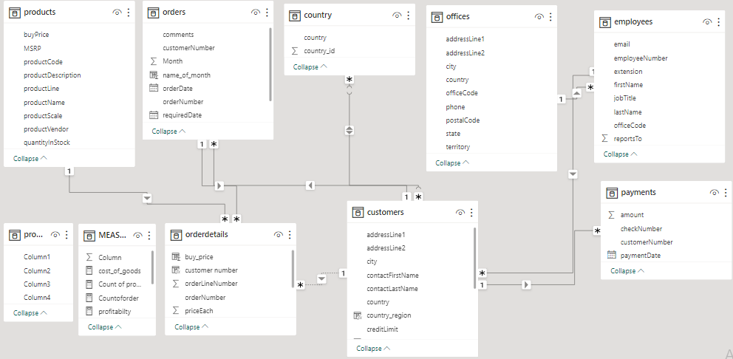

**POWER BI PROBLEM SOLVING STATEMENTS**

1.How does monthly revenue vary across different product categories?

As I reviewed the monthly revenue data across different product categories, several key insights and observations emerged. This self-analysis note aims to outline how monthly revenue varies among these product categories, emphasizing the significance of these variations and potential areas for further analysis.

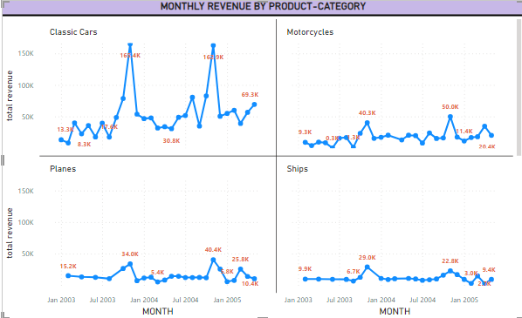

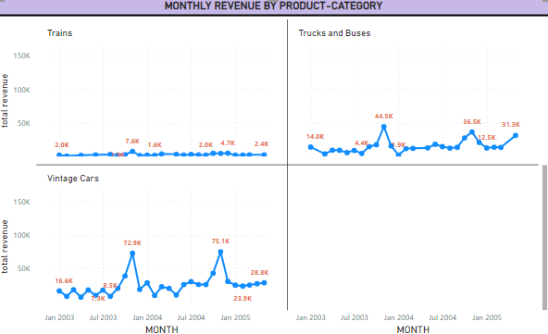

2.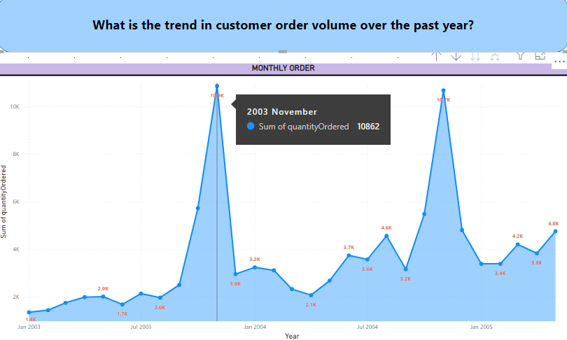

**When examining the trend chart showing monthly customer orders over the past years, several valuable insights can be gained regarding the trend in customer order volume:**

**By seeing the chart, it is visible that the seasonal month is November because sales quantity is highest over the year in the month of November**

3. How does the sales performance of top customers compare to the rest?

4.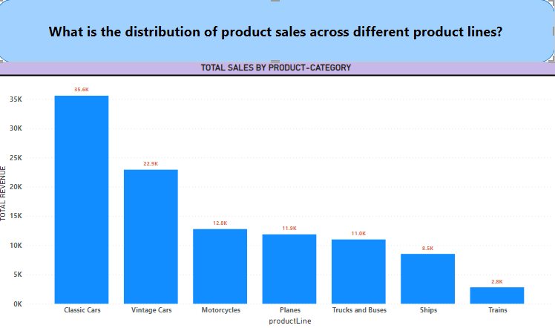

It is visible from the graph that classic cars have the highest sales among all category which is 35.6k

Then vintage cars with 22.9k and so on so we can conclude that classic cars have the highest sales among

All the other product lines.

5.

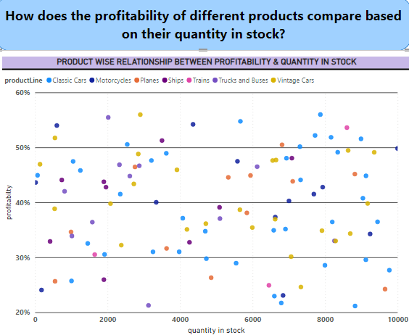The scatter plot chart depicting the connection between the quantity in stock and profitability provides essential insights into the company's operations.

This graph is showing the correlation between profitability and quantity in stock by each product,

So it is visible from the graph that products which have the profitability range between

30% to 50% are mostly sold products.

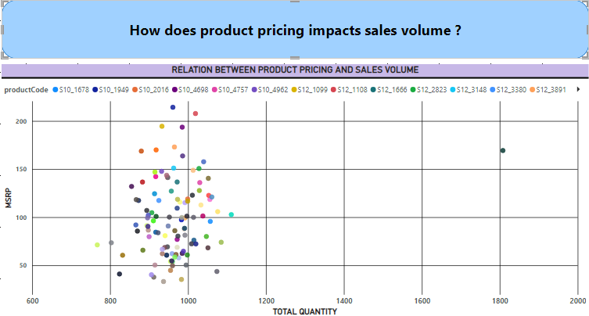6.

The scatter plot chart displaying the impact of product pricing on sales volume offers critical insights into the dynamics of pricing and consumer behavior. One notable trend that emerges is the presence of a nonlinear relationship between these two variables. Initially, as product pricing increases, there is often a decrease in sales volume, suggesting that higher prices can deter some potential customers.

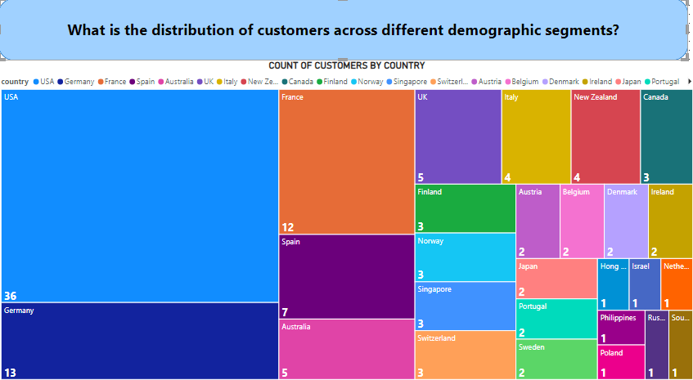7.

This tree map is showing the distribution of customers across different countries , so we can see that USA has the highest number of customers count which is 36 then Germany having 13 customers and so on and we can also see that there are some countries where count of customers are very low so these are the potential market where count of customers can be increased.

8.

9.

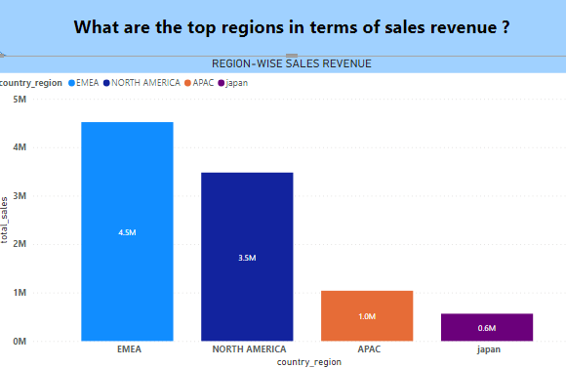10.

EMEA is the region with highest sales then north America and so on region with least sales is Japan

so, Japan and APAC are the regions where sales revenue compared to other regions are very low.

so, these markets need more focus so that sales can increase.

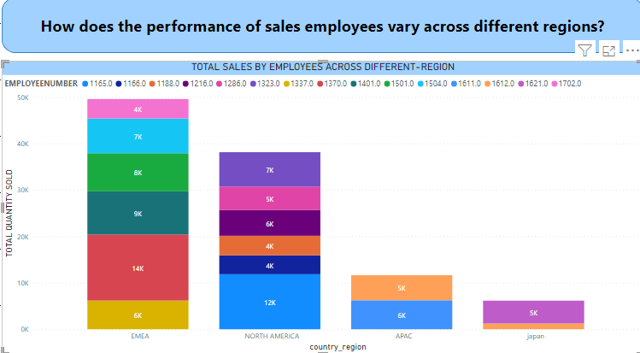11.

This stacked bar chart provides us the insights regarding region wise sales performance of each employee, Different regions have varying levels of market demand for the products or services offered. Larger regions with higher populations or more businesses offer more opportunities for sales, leading to potentially higher sales performance.

12.

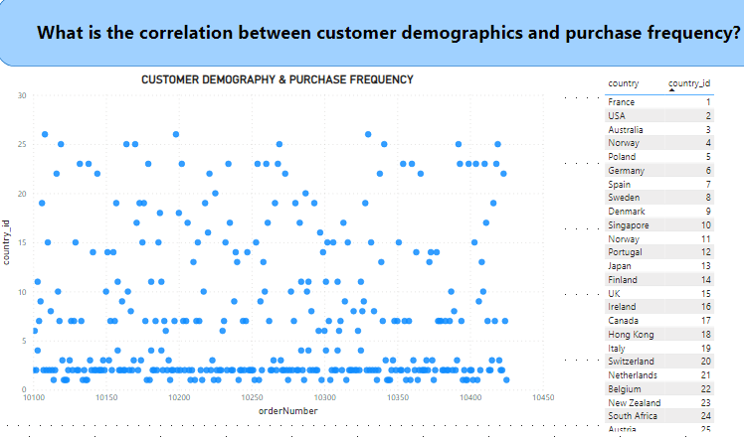

This scattered plot graph shows correlation between customers demography and purchase frequency .

EDA PROBLEM STATEMENT

1. **Which factors contribute to the highest sales in a particular region?**

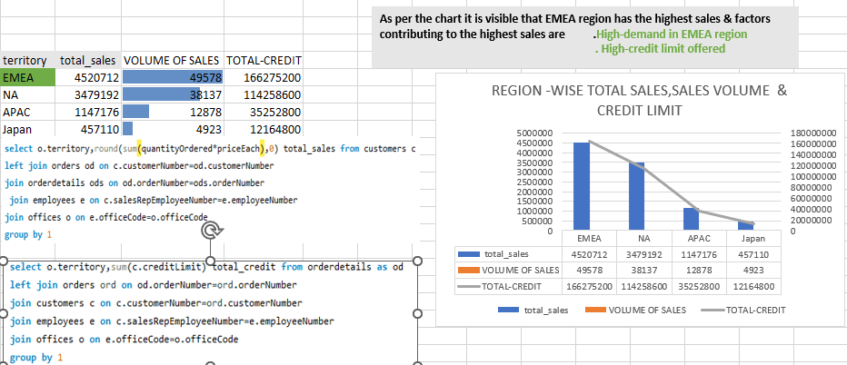

**How can customer purchasing patterns be influenced to increase average order value?**

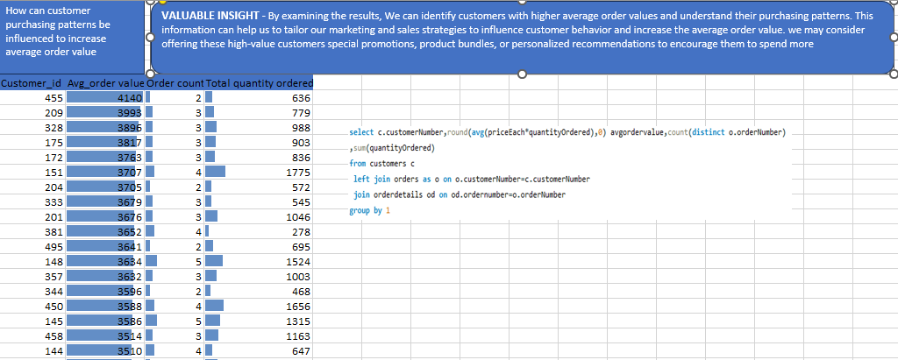**VALUABLE INSIGHT** - By examining the results, we can identify customers with higher average order values and understand their purchasing patterns. This information can help us to tailor our marketing and sales strategies to influence customer behavior and increase the average order value. We may consider offering these high-value customers special promotions, product bundles, or personalized recommendations to encourage them to spend more.

**What are the key drivers of sales growth, and how can they be leveraged for future success?**

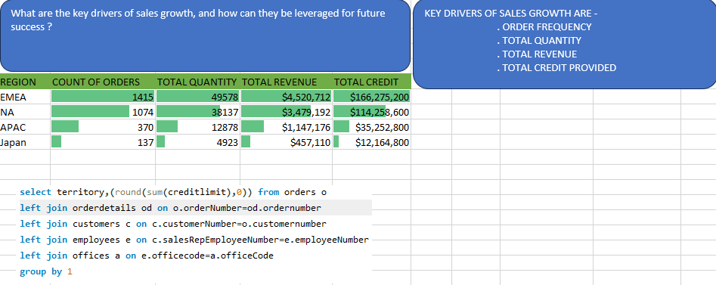

* **KEY DRIVERS OF SALES GROWTH ARE -**
* **. ORDER FREQUENCY**
* **. TOTAL QUANTITY**
* **. TOTAL REVENUE**
* **. TOTAL CREDIT PROVIDED**

**Which product features or attributes are most appealing to customers?**

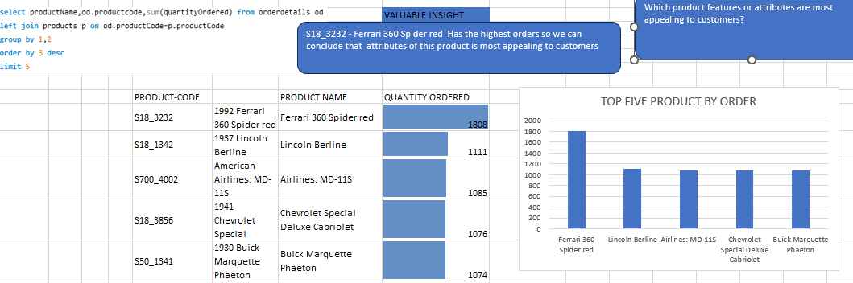**S18_3232 - Ferrari 360 Spider red Has the highest orders so we can conclude that attributes of this product are most appealing to customers.**

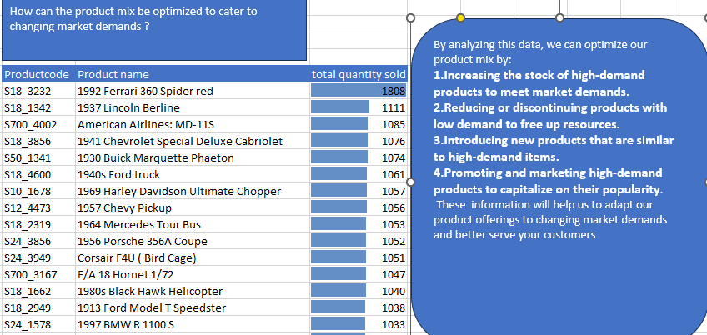**How can the product mix be optimized to cater to changing market demand ?**

1. Are there any specific market segments where a particular product is underperforming, and how can it be improved?

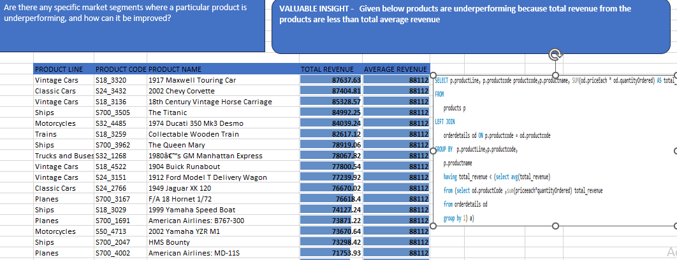

**VALUABLE INSIGHT - Given products are underperforming because total revenue from the products is less than total average revenue.** **To improve underperforming products, businesses can take several steps. Firstly, conducting thorough market research and customer feedback analysis helps identify specific weaknesses and areas for enhancement. Once issues are pinpointed, product redesign, feature improvements, or quality enhancements can be implemented.**

1. What are the main factors that influence customer loyalty and repeat purchases?

Given below is the list of the top 10 most valuable customers.

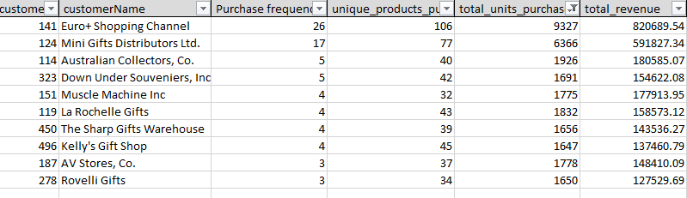

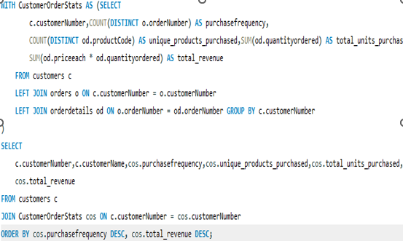

These information’s about customers’ behavior helps us to identify patterns and factors that influence customer loyalty and repeated purchase **purchase frequency, unique products purchased, total units purchased, total revenue.**

8.How do customer preferences differ based on geographic location, and how can marketing campaigns be customized accordingly?

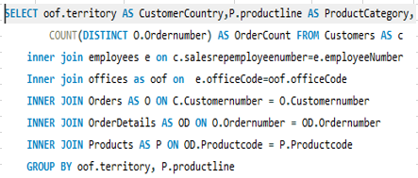

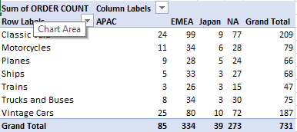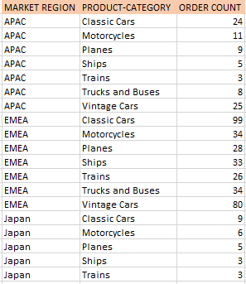

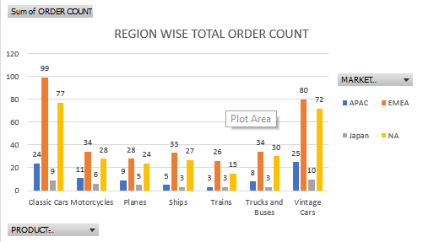

Customer preferences vary by geographic location due to cultural, environmental, and economic factors. To customize marketing campaigns effectively, it's crucial to conduct in-depth market research in each region. Tailor product offerings and messaging to align with local tastes and needs. Use localized content, language, and imagery that resonate with the target audience. consider regional trends and sensitivities. Lastly, leverage data analytics to continually refine campaigns, ensuring they remain relevant and engaging to local customers.

9.What are the characteristics of high-value customers, and how can similar customers be targeted for acquisition?

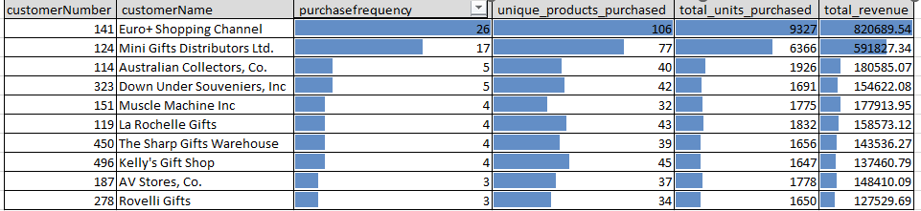



10.

**How can marketing strategies be tailored to target specific demographic segments in different regions ?**

**Segmentation and Data Analysis**:

Begin by segmenting your customer base based on demographic factors such as age, gender, income, education, and location. Identify which demographics are most relevant to each region.

Analyze customer data to understand the preferences, behaviors, and purchasing patterns of each demographic segment within each region.

**Market Research**:

Conduct market research to gain insights into the cultural and regional nuances of each target market. Understand local customs, languages, and consumer behaviors.

Identify specific needs and pain points that are unique to each region and demographic group.

**Product Customization**:

Customize products or services to meet the specific needs of different regions and demographic segments. This might involve offering regional variations, sizes, or features.

Highlight the benefits and features that are most relevant to each group

**Timing and Frequency**:

Adjust the timing and frequency of marketing campaigns to align with regional and demographic preferences. This includes considering factors like local holidays and peak shopping seasons

12.

**How do customer preferences and behavior differ based on demographic factors, and how can they be leveraged for personalized marketing campaigns?**

|  |  |  |  |  |  |
| --- | --- | --- | --- | --- | --- |
| **Sum of ORDER COUNT** | **Column Labels** |  |  |  |  |
| **Row Labels** | **APAC** | **EMEA** | **Japan** | **NA** | **Grand Total** |
| Classic Cars | 24 | 99 | 9 | 77 | 209 |
| Motorcycles | 11 | 34 | 6 | 28 | 79 |
| Planes | 9 | 28 | 5 | 24 | 66 |
| Ships | 5 | 33 | 3 | 27 | 68 |
| Trains | 3 | 26 | 3 | 15 | 47 |
| Trucks and Buses | 8 | 34 | 3 | 30 | 75 |
| Vintage Cars | 25 | 80 | 10 | 72 | 187 |
| **Grand Total** | **85** | **334** | **39** | **273** | **731** |

. **VALUABLE INSIGHT- DATA & visual helps us to understand purchasing pattern of different product category based on regions, it shows region wise customer preferences & behavior for different product category**

. By understanding how customer preferences and behavior differ based on demographic factors and tailoring our marketing strategies accordingly, we can create more personalized and effective marketing campaigns that resonate with our target audience. This, in turn, can lead to higher engagement and conversions.

11.

**What are the potential untapped markets based on demographic indicators, and how can market penetration be increased**

|  |  |  |  |
| --- | --- | --- | --- |
| Country | City | customer count | order count |
| Germany | Aachen | 1 | 0 |
| Germany | Berlin | 1 | 0 |
| Germany | Brandenburg | 1 | 0 |
| Germany | Cune walled | 1 | 0 |
| Germany | Leipzig | 1 | 0 |
| Germany | Mannheim | 1 | 0 |
| Germany | MÃ¼nchen | 1 | 0 |
| Germany | MÃ¼nster | 1 | 0 |
| Germany | Stuttgart | 1 | 0 |
| Ireland | Cork | 1 | 0 |
| Israel | Herzliya | 1 | 0 |
| Netherlands | Amsterdam | 1 | 0 |
| Poland | Warszawa | 1 | 0 |
| Portugal | Lisboa | 2 | 0 |
| Russia | Saint Petersburg | 1 | 0 |
| South Africa | Hatfield | 1 | 0 |
| Switzerland | Bern | 1 | 0 |
| Switzerland | Fribourg | 1 | 0 |

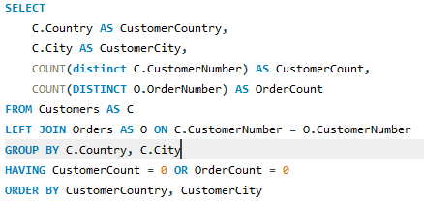

* VALUABLE INSIGHT - Given data provides us the details of cities where the order count is 0 which clearly indicates an opportunity in these market , these markets are untapped . . To increase market penetration in these untapped markets, we can consider strategies such as targeted marketing campaigns, local promotions, expanding product offerings, and improving customer outreach in these regions.